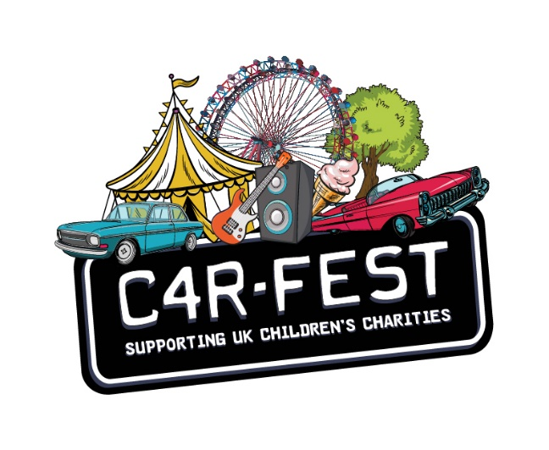

In this form:

- Application process
- Personal details
- Attendance at the festival
- Access Provision
- Information and evidence
- Accessible camping information
- Accessible camping
  - Tents
  - Campervans
  - Power
- Other information

Access Requirement Form

Part 1: Application Process

This is the process by which bookable access facilities can be requested:

- Purchase the tickets you require, minus the PA Ticket or the disabled childs ticket
- Obtain a ticket reference number
- Send us your completed Access Requirement Form (only valid with a ticket reference number) and any supporting evidence.
- We will endeavour to respond within 2 weeks to confirm your requests
- We will then send you a confirmation email, and further arrival instructions

Submitting your form

Email your completed from to: access@carfest.org

Submitting supporting documents
When submitting documents to support your application, we ask that you:

- Scan/take a photo of evidence and attach it with your form if emailing

Part 2: Personal Details

Ticket Reference Number
Name on the booking:
Tel:
Email of booker:

Name of disabled customer if different:
*Age group of disabled customer: 0-5 6-16 17+

*If applying for a free Essential Companion ticket for a disabled adult, an adult ticket of the same type will be allocated.
However, if the disabled customer is a child, a free child’s ticket will be allocated.

Carfest do not provide the ‘purchase and payback’ scheme. Do not purchase tickets for Essential Companions or disabled children.

Part 3. Attendance at the Festival

Ticket Type
Standard Premium

Camping Customers
Please let us know what days you will arrive at the festival:

Thursday (Early Entry) Must be purchased when booking tickets. Friday (Weekend)

Day Ticket Customers
Please let us know which day(s) you will be attending the festival:

Friday SaturdaySunday

Part 4. Access Provision Request

Please check the box next to the access provision you are requesting. You may select more than one.

- A Free Ticket for a Personal Assistant/Essential Companion
- Free disabled child’s ticket
- Viewing Platform Access*
- A Pitch in the Accessible Campsite (please fill in Part 6 at the bottom of this form)
If you are camping in another campsite, please state here
- Access to a hoist for toileting/changing(Changing Places Unit)
- Access to accessible toilets
- Use of a fridge for storage of medication
- Powered-wheelchair/scooter/medical machinery charging point

Day Tickets holders of Blue Badges are able to park in the Blue Badge Carpark without a Parking Pass.
Camping customers will have access to the Accessible Camping Carpark if you are booked on this site.

*Please note that viewing platform access spaces are allocated on a first-come, first-served basis. By ticking the above boxes, you are indicating that you would like to utilise these provisions, but we cannot guarantee access to everyone.
Assistance Dogs with recognised certification are welcome on site but must be pre agreed with the Access Team.
I wish to bring an assistance dog and have attached the following evidence

Part 5. Information / Evidence
Evidence is required for all of the above requests.
Photographic ID from the disabled guest may be required before wristbands are issued.

Documents taken into account
A photocopy / scan of one of the following documents (dated within the past 12 months if DLA, PIP or Attendance Allowance). Please check the box next to the evidence you wish to submit:

Front page of DLA or PIP award
Front page of Attendance Allowance award
Front page of War Disablement Pension Certificate of visual impairment (CVI) Recognised Assistance Dog ID card None of the above (see below)

Statement (with option to send alternative evidence)
We recognise that the evidence above is not definitive. If you do not have any of the above evidence but wish to apply for the above access facilities, use the box below to state why you require them:

Please email copies of any additional evidence that supports your application if you have any, or contact us to discuss your application. Your application will be judged on a case-by- case basis.

Part 6. Accessible camping information
The Accessible Campsite at CarFest is available to camping ticket holders. There are accessible toilets, accessible showers, Changing Places Unit, power chair/scooter charging tent and a medical/specialist food fridge in the accessible campsite. There is also a dedicated member of staff located in this field 24 hours a day, so please approach them if you have any access requirements or questions.

Please note that a maximum of 5 people (including yourself and your Personal Assistant) may camp in one pitch. All groups are asked to abide by this so that we can fit as many people in the campsite as possible.

Tents
As we need to calculate the size of the area required for camping, please indicate how many people are in your party and how many tents you are bringing.Total number of tents: 1 2 3

How many additional people will be coming with you:

1 2 3 4

Caravans/Campervans

Carfest want everyone to enjoy the festival and understand that some people may not be able to attend as it is impossible for them to camp in a tent.
Due to this we offer free CV permits (without power but with option to request this later in the form) to those guests.
For any other guest who wish to bring a campervan/caravan, you will have the option to purchase an Access CV permit with power or change your already purchased CV permit to an Access one.

Free Permits (without power)
Campervan permits (without power) will only be provided free of charge to those people who are unable to camp in a tent due to their impairment.

Please explain why you are unable to camp in a tent and indicate the type of van you are bringing?

Campervan Caravan

Please let us know how many additional people will be coming with you: 1 2 3 4
Completing the above does not guarantee you a free permit and you will be informed if you
qualify.

Purchase a CV permit for Access Campsite
Do you wish to purchase an ‘Access’ CV permit (includes power)? Campervan Caravan
Please let us know how many additional people will be coming with you:

1 2 3 4

You will be sent a link to purchase the Access Campsite CV permit.

If you have already purchased a permit for the general CV site, please let us know and we will change this to an Access permit.
Please provide your permit booking number

Power
Power can be provided free of charge if you have a proven medical need or purchased if you have been provided with a free CV permit but do not require power for a proven medical need.

Power cannot be purchased for those camping in tents.

Do you require free of charge power to your caravan or tent for medical equipment/need (e.g. CPAP machine)

Yes Please tell us what equipment you will be bringing and email any evidence.

Do you wish to purchase power for a free CV permit. Yes You will be sent a link to purchase this.

Part 8. Other information

Please inform us if you have any additional access requirements.
We shall make every effort to make reasonable adjustments to meet your needs

Please note that all collected data will automatically be deleted after the event. We will not share your data with any third party organisations.

If any of your access requirements change prior to the event please be sure to inform us at the earliest opportunity so that we can do our best to ensure these needs are met.

